SMT Z.S Patel College of Computer Application
Affiliated to
Veer Narmad South Gujarat University, Surat.



Project Report on,
Student Study Habits & Performance Analyzer
As a Partial Requirement for Degree of
Bachelor of Computer Application
(BCA) 2025 – 2026

Submited By: ___________________ , ___________________
Project Guide: ___________________
Acknowledgement
I would like to express my special thanks of gratitude to my Project Guide [Project Guide’s Name] as well as our principal [Principal's Name] who gave me the golden opportunity to do this wonderful project on the topic "Student Study Habits & Performance Analyzer", which also helped me in doing a lot of Research and I came to know about so many new things.

Project Description

Project Title: Student Study Habits & Performance Analyzer

Objective:
The main objective of this project is to analyze student behavioral data to understand the impact of various study habits on academic performance. The project aims to identify correlations between study hours, sleep patterns, attendance, and exam scores, providing data-driven insights for educational improvement.

Dataset:
The dataset used is a CSV file containing records of students with attributes regarding their daily habits and academic results. The data is suitable for statistical analysis and visualization.

The dataset contains the following columns:
Coulmn | Description
hours_studied | Number of hours the student studies daily
sleep_hours | Daily sleep duration in hour
attendance_percent | Percentage of classes attended by the student
exam_score | Final examination score achieved

Tools & Technologies:
Tools | Description
Python | Core programming language.
pandas | For data manipulation and analysis.
matplotlib | For creating data visualizations (graphs and charts).
Visual Studio Code | Integrated Development Environment (IDE).

Methodology:
Tools | Description
Data Loading | Load the student dataset from a CSV file using the `pandas` library.
Data Inspection | check for missing values and understand the data structure.
Statistical Analysis | Group data to calculate averages (e.g., average score vs. sleep
Data Loading | Load the student dataset from a CSV file using the `pandas` library.

Visualization:
- Create a Scatter Plot to observe the relationship between study hours and exam scores.
- Create a Histogram to analyze the distribution of student attendance.
- Create a Bar Chart to compare average exam scores across different sleep durations.

User Interface: Implement a CLI (Command Line Interface) menu for users to select different analysis modules.

import os
import pandas as pd
import matplotlib.pyplot as plt
from matplotlib.ticker import MaxNLocator

# ==========================================
# CONFIGURATION
# ==========================================
DATA_FILE = 'students_data.csv'

# ==========================================
# DATA HANDLING
# ==========================================
def load_data():
"""
Loads the student dataset from the CSV file.
Returns:
pd.DataFrame: The loaded data if successful.
None: If the file is missing or corrupt.
"""
if not os.path.exists(DATA_FILE):
print(f"\n[ERROR] File '{DATA_FILE}' not found.")
print("Please ensure the CSV file is in the same directory.")
return None

try:
df = pd.read_csv(DATA_FILE)
print(f"\n[SUCCESS] Successfully loaded {len(df)} student records.")
return df
except Exception as e:
print(f"\n[ERROR] Failed to read file: {e}")
return None

def show_data(df):
"""Displays the first 20 rows and dataset info."""
print("\n" + "="*50)
print(f" DATA PREVIEW (First {min(len(df), 20)} Rows)")
print("="*50)
print(df.head(20).to_string(index=False))
print("-" * 50)
print(f"Total Records: {len(df)}")
print(f"Columns: {', '.join(df.columns)}")

# ==========================================
# VISUALIZATION FUNCTIONS
# ==========================================
def plot_study_vs_score(df):
"""
LINE CHART: Analyzes relationship between Study Hours and Exam Score.
"""
# Sort by study hours for a clean line plot
df_sorted = df.sort_values(by='hours_studied')

plt.figure(figsize=(10, 6))
plt.plot(df_sorted['hours_studied'], df_sorted['exam_score'],
color='royalblue', marker='o', linestyle='-', linewidth=2, markersize=6)

plt.title('Trend: Study Hours vs. Exam Score', fontsize=14, fontweight='bold')
plt.xlabel('Hours Studied (Daily)', fontsize=12)
plt.ylabel('Exam Score (%)', fontsize=12)
plt.grid(True, linestyle='--', alpha=0.6)

print("\n[GRAPH] Displaying Line Chart...")
plt.show()

def plot_attendance_distribution(df):
"""
BAR CHART: Visualizes the distribution of student attendance in bins.
"""
# Create bins for attendance
bins = [0, 50, 60, 70, 80, 90, 100]
labels = ['<50%', '50-60%', '60-70%', '70-80%', '80-90%', '90-100%']

# Cut the data into bins
attendance_cats = pd.cut(df['attendance_percent'], bins=bins, labels=labels, right=True)
counts = attendance_cats.value_counts().sort_index()

plt.figure(figsize=(10, 6))
counts.plot(kind='bar', color='mediumseagreen', edgecolor='black', alpha=0.8)

plt.title('Distribution of Student Attendance', fontsize=14, fontweight='bold')
plt.xlabel('Attendance Range', fontsize=12)
plt.ylabel('Number of Students', fontsize=12)
plt.xticks(rotation=45)
plt.gca().yaxis.set_major_locator(MaxNLocator(integer=True))

print("\n[GRAPH] Displaying Bar Chart...")
plt.show()

def plot_sleep_impact(df):
"""
PIE CHART: Shows distribution of students by sleep duration.
"""
df_plot = df.copy()
df_plot['sleep_rounded'] = df_plot['sleep_hours'].round()

# Count students for each sleep duration
sleep_counts = df_plot['sleep_rounded'].value_counts().sort_index()

plt.figure(figsize=(8, 8))
plt.pie(sleep_counts, labels=[f"{int(h)} Hours" for h in sleep_counts.index],
autopct='%1.1f%%', startangle=140,
colors=plt.cm.Pastel1.colors)

plt.title('Distribution of Students by Sleep Duration', fontsize=14, fontweight='bold')

print("\n[GRAPH] Displaying Pie Chart...")
plt.show()
# ==========================================
# MAIN APPLICATION LOOP
# ==========================================
def main_menu():
"""Displays the main interactive menu."""
df = load_data()
if df is None:
return

while True:
print("\n" + "="*50)
print(" STUDENT PERFORMANCE ANALYZER")
print("="*50)
print(" 1. View Raw Data")
print(" 2. Visualize: Study Hours vs Score (Line Chart)")
print(" 3. Visualize: Attendance Distribution (Bar Chart)")
print(" 4. Visualize: Sleep Distribution (Pie Chart)")
print(" 5. Exit Application")
print("="*50)

choice = input(" Enter your choice (1-5): ").strip()

if choice == '1':
show_data(df)
elif choice == '2':
plot_study_vs_score(df)
elif choice == '3':
plot_attendance_distribution(df)
elif choice == '4':
plot_sleep_impact(df)
elif choice == '5':
print("\nExiting Application. Goodbye!")
break
else:
print("\n[!] Invalid choice. Please try again!!")

if __name__ == "__main__":
try:
main_menu()
except KeyboardInterrupt:
print("\n\nProgram interrupted by user. Exiting...")

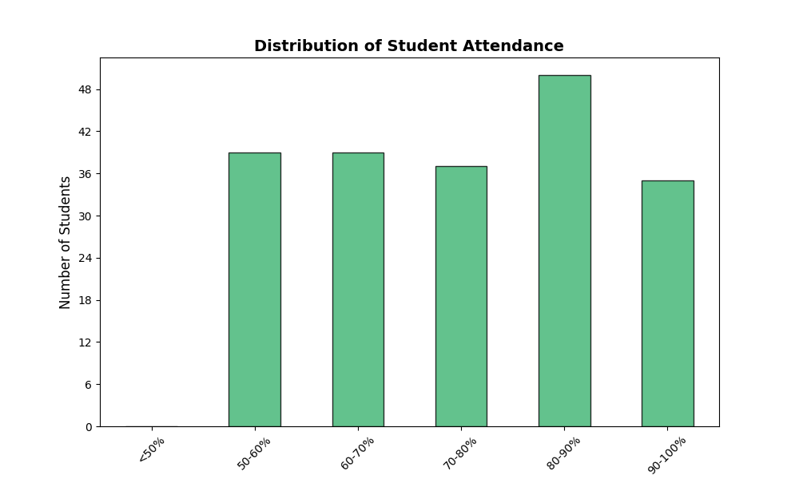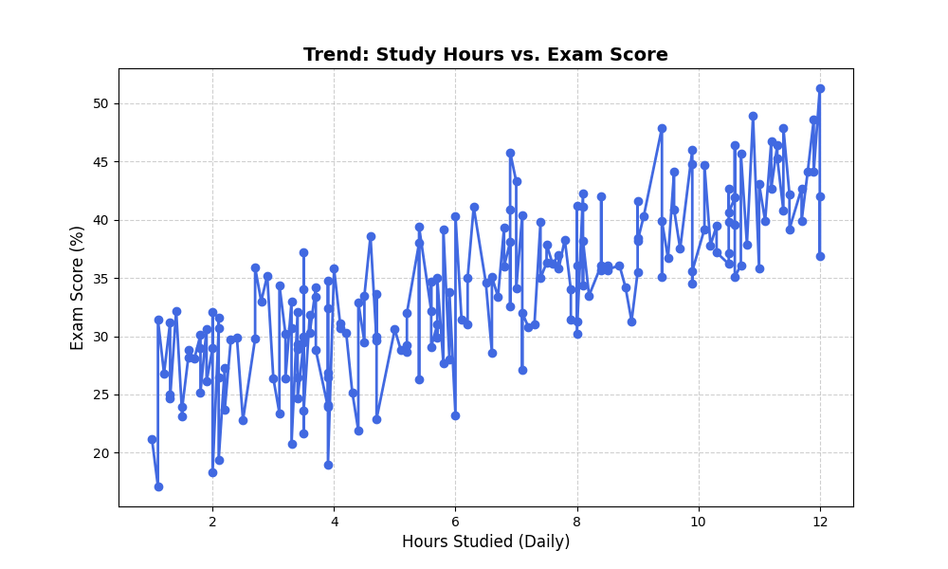
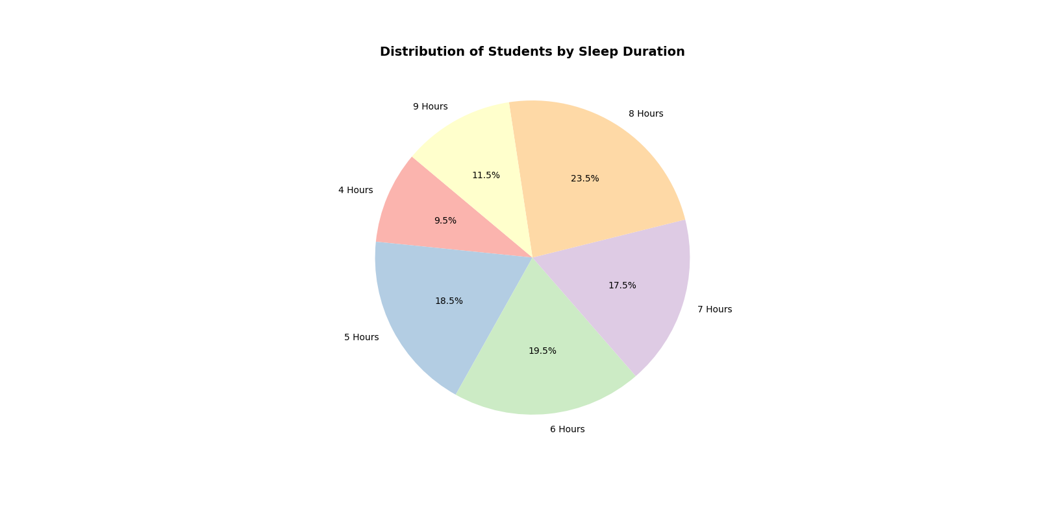
Conclusion:
The project successfully demonstrates how Python can be used for educational data analytics. It reveals patterns indicating that while consistent study hours positively correlate with higher scores, adequate sleep and regular attendance are also critical factors for optimal academic performance. This tool serves as a practical example of applying data science concepts to real-world scenarios.

